Url Slug Suggestion - https://rootcabs.com/cities/taxi-in-kumbakonam
Primary Keyword
taxi service kumbakonam
best taxi service in kumbakonam
drop taxi kumbakonam
Secondary Keyword
kumbakonam taxi packages
one way drop taxi kumbakonam
cab in kumbakonam
cab service in kumbakonam
call taxi at kumbakonam
call taxi service in kumbakonam
kumbakonam cabs tariff
kumbakonam call taxi service
kumbakonam one way taxi
kumbakonam taxi
taxi in kumbakonam

Page Layout

H1 - Looking for Taxi Service in Kumbakonam?

H2 - Fare Calculator
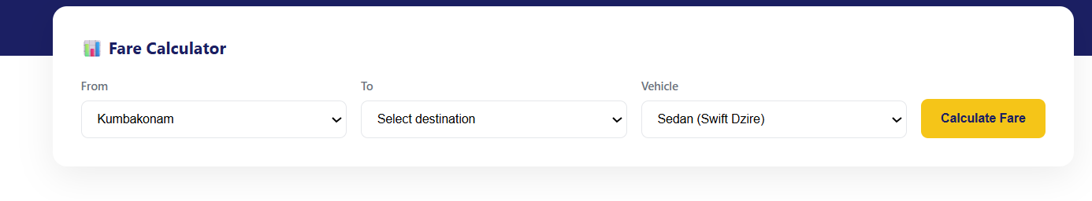

H2 - Services Available in Kumbakonam


H2 - Popular Routes from Kumbakonam (Define the header in two lines below this header)
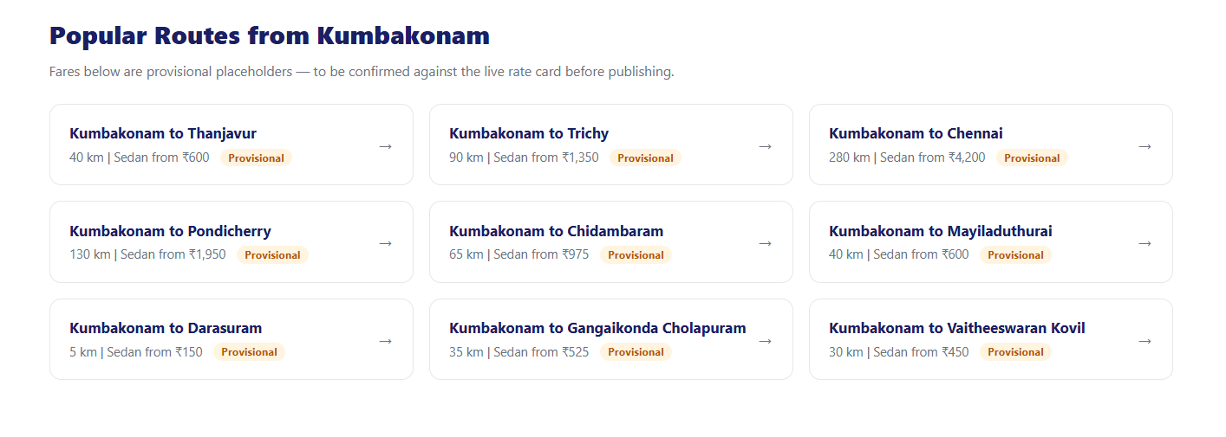

H2 - Popular Pickup Spots In Kumbakonam
Define the header in two lines below this header
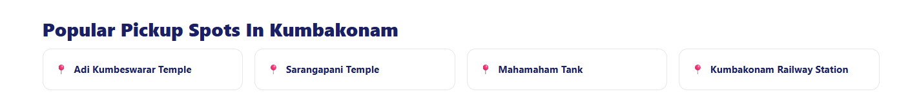

H2 - Navagraha Temple Circuit from Kumbakonam
H3 - Thirunageswaram (Rahu Temple)
H3 - Suryanar Kovil (Sun Temple)
H3 - Vaitheeswaran Kovil (Mars Temple)
H2 - Great Living Chola Temples (UNESCO) Near Kumbakonam
H3 - Airavatesvara Temple, Darasuram
H3 - Brihadeeswarar Temple, Thanjavur
H3 - Gangaikonda Cholapuram
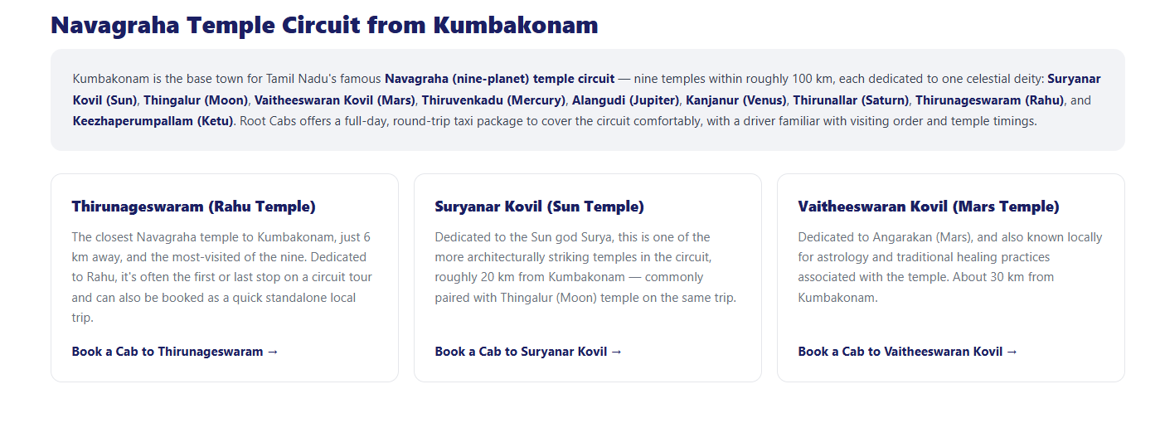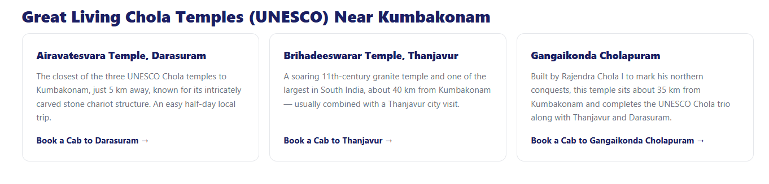

H2 - Customer Reviews in Kumbakonam (write three customer reviews )



H2 - Why Choose Root Cabs in Kumbakonam?
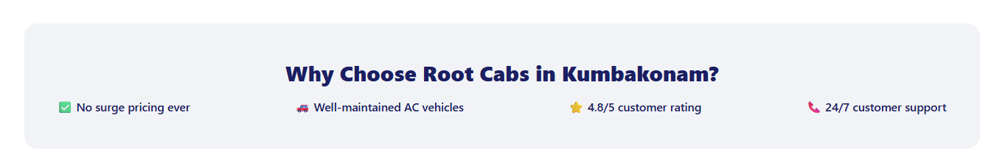
H2 - Driving With Root Cabs in Kumbakonam
H3 - Become a Driver Partner
H3 - Need an Acting Driver?
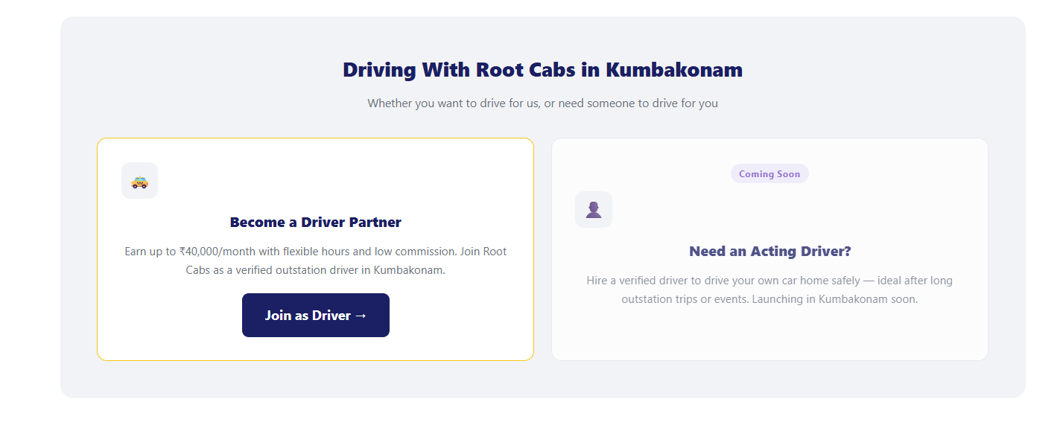

Acting driver section added - Purpose interlinking to the acting driver page.
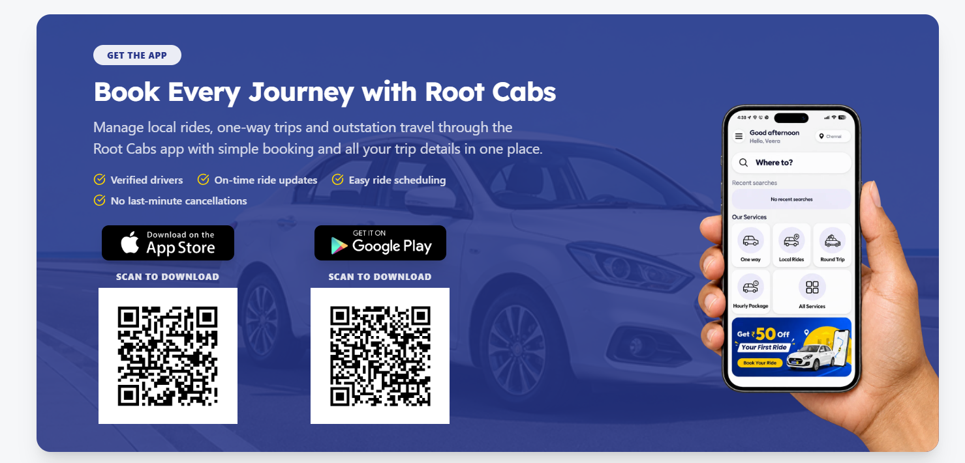

H2 - Frequently Asked Questions
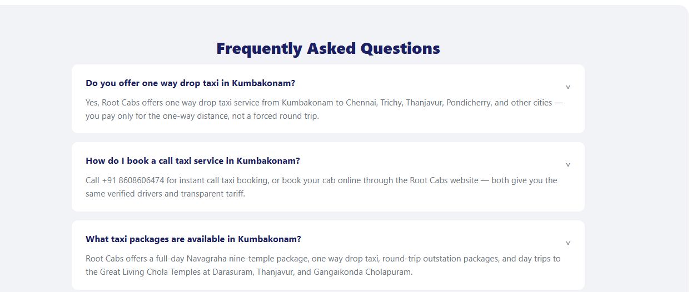
How much does a taxi cost in Kumbakonam?
What are the taxi service rates in Kumbakonam?
How do I book Kumbakonam taxi online?
Is there a 24 hours taxi service in Kumbakonam?
What are the Kumbakonam taxi packages and prices?
Which is the cheapest taxi service in Kumbakonam?

